EV Charging Station Finding Web App

Project submitted to the
SRM University – AP, Andhra Pradesh
for the partial fulfillment of the requirements to award the degree of

Bachelor of Technology
In
Computer Science and Engineering
School of Engineering and Sciences

Submitted by
DEEPAK DAS TATWA(AP22110011485)
PUJITHA POTLURI(AP22110011486)
MNH SRAVYAVANI(AP22110011456)

Under the Guidance of
Dr.Randhir Kumar
SRM University–AP
Neerukonda, Mangalagiri, Guntur
Andhra Pradesh – 522 240
APRIL 2025
Acknowledgement

We would like to express our sincere gratitude to Dr. Randhir Kumar, our project guide, for his continuous support, valuable guidance, and encouragement throughout the development of this project, EV ChargingStation Finding Web App. His insights and expertise have been instrumental in helping us understand the core concepts and shaping the direction of our work.

Our appreciation also goes out to our teammates for their consistent efforts, collaborative spirit, and dedication during all phases of the project.
Lastly, we are grateful to friends for their unwavering support and patience during the course of this journey.

ABSTRACT
The EV Charging Management System is a web-based platform which is created to help Electric Vehicle (EV) users optimize the process of searching for and managing charging stations. With the increased adoption of charging stations, the infrastructure supporting their usage increasing in prevalence has become crucial. This system allow users search for stations along a specified geographical location, reserve slots beforehand and get updates in real-time about the availability of charging slots which minimizes waiting times and maximizes comfort during travel.
The system comprises two major modules:
User Module: Empowers EV users to manage cars, look for stations, reserve charging slots, and plan trips.
Administration Module: Allows the admin to view and edit information about the charging stations, manage user bookings, supervise the effectiveness of charging stations, and respond to complaints.
Station Owner Module: Enables the station owner to accept the booking of the user and manage the availability of the stations.
The application is developed in React.js along with Next.js for the backend of the system, and the database is handled in Firebase. Using the Google Maps API for planning routes and JWT for authentication.
This scalable and user-friendly system enhances EV charging accessibility, reduces range anxiety, and contributes to the adoption of sustainable energy solutions.

Table of Content
Acknowledge…………………………………………………………………………………2
Abstract ……………………………………………………………………………….3
Problem Statement ……………………………………………………………………5
Process Model ………………………………………………………………………...6
Chapter 1: Introduction ………………………………………………………………..7
1.1 Purpose …………………………………………………………………….7
1.2. Scope ………………………………………………………...……………8
1.3. Definitions, Acronyms, and Abbreviations ……………………………….8
1.4. References …………………………………………………………………9
1.5. Overview …………………………………………………………………..9
Chapter 2: Software Requirement Specification (SRS) ………………………………..10
2.1. User Interfaces …………………………………………………………….10
2.2. System Interfaces ………………………………………………………….10
2.2.1 Hardware Interfaces ………………………………………10
2.2.2 Software Interfaces ……………………………………….10
2.3. System Specifications ……………………………………………………...11
2.3.1 Hardware Requirements ……………………………………………….11
2.3.2 Software Requirements ………………………………………………...11
2.4. Communication Interfaces …………………………………………………11
2.5. Product Functions …………………………………………………………11
2.6. Data Flow Diagrams (DFD) ………………………………………………13
2.6.1 Level 0 DFD ………………………………………………………….13
2.6.2 Level 1 DFD…………………………………………………………..15
2.7. Use-Case Diagram ………………………………………………………..17
2.8. Entity Relationship (ER) Diagram ……………………………………….19
2.9. Sequence Diagrams ………………………………………………………22
2.9.1 Book Station ……………………………………………………….…22
2.9.2 Login ……………………………………………………………….…24
2.9.3 Search Stations …………………………………………………..……25
2.9.4 Update Station Availability ……………………………………...……26
2.9.5 Add Stations ……………………………………………………..……27
2.9.6 Cancel Bookings ………………………………………………………28
Web Application Overview ……………………………………………………………30
Conclusion …………………………………………………………………………….44

Problem Statement
Electric vehicles and charging technology have advanced significantly in the last ten years. Because they can use regenerative braking to recharge their batteries while driving, electric vehicles not only help reduce emissions but also have superior power delivery and are significantly more efficient.
Even with all of their benefits, electric cars still have drawbacks, like difficulty locating charging stations. Owners of electric vehicles are unable to recharge their vehicles at any gas station, in contrast to those who drive conventional cars. Electric vehicle owners must ensure their vehicles are fully charged before they leave.
The need for developing infrastructure such as charging stations is undeniable.

Benefits of Implementing the EV Charging Station
- Enhanced Availability – Users are able to search for specific charge stations based on their location, city, or distance.
- Better Queue Management – Users are able to book slots in advance which guarantees availability, and thus reduces waiting time at the charging stations.
- Efficient Journey And Charge Planning – This feature gives plans the ability to travel long distances by providing Electric Vehicle Users with charge stations according to the electric vehicle user's route.
- Lowered Travel Anxiety – Thoughtful and systematic allocation of charge stations allows users to plan their trips without worrying.
- Expandability & Future Growth – The infrastructure can be deployed in smart cities, on expressways, and on EV corporate fleets, making this service part of the larger EV infrastructure.
- Supports Sustainable Development – Makes e-mobility more accessible and user-friendly which increases environmental responsibility as the primary form of transportation.

Process Model
The Agile Model is the most suitable software development approach for the EV Charging Management System due to its flexibility, user-centric design, and iterative improvements. Given that the system relies on real-time station availability, user bookings, and route planning, Agile ensures frequent updates and quick adaptations based on user feedback. Its incremental development approach allows seamless integration of future enhancements such as dynamic pricing, AI-based recommendations, and IoT-based smart charging. Agile also promotes continuous collaboration among developers, testers, and stakeholders, ensuring faster deployment and higher software quality. Additionally, since the system depends on real-time data, Agile helps in early risk detection and resolution, preventing major failures after deployment. This makes it an ideal choice for scalable, secure, and user-friendly EV charging solutions.

Chapter 1
Introduction
1.1 PURPOSE
1.2 SCOPE
1.3 DEFINITIONS, ACRONYMS, and ABBREVIATIONS
1.4 REFERENCES
1.5 OVERVIEW

1.1 PURPOSE
The EV Charging Management System is a web-based platform designed to enhance the accessibility and efficiency of electric vehicle (EV) charging infrastructure. This system allows users to search for charging stations based on location, reserve slots in advance, and receive real-time updates on slot availability. By integrating route optimization and booking features, the platform ensures that EV owners can plan their journeys with minimal disruptions. The system also includes an administrative module that allows station operators to manage bookings, monitor charging station usage, and maintain a seamless charging experience for users.
Currently, EV users rely on mobile apps and websites provided by individual charging networks or third-party aggregators to find charging stations. These solutions provide basic functionalities like station location and availability status. However, many of these platforms lack real-time slot booking, comprehensive route planning, or an integrated system that connects multiple charging networks into a single platform. As a result, EV users often struggle with fragmented information and have to rely on multiple sources to plan their trips effectively.
Despite the availability of existing solutions, EV users frequently encounter challenges such as inaccurate station availability, long wait times at charging stations, and difficulty in finding an optimal route with sufficient charging stops. Additionally, many existing systems do not support pre-booking, causing uncertainty for users, especially during peak hours. This inefficiency leads to frustration and increased range anxiety, discouraging wider EV adoption.
Our EV Charging Management System addresses these challenges by integrating real-time station updates, slot booking, and smart route planning into a single, user-friendly platform. By allowing users to reserve charging slots in advance and providing optimized travel routes with charging stations along the way, the system minimizes wait times and ensures smooth long-distance travel. Additionally, the administration module improves station management, ensuring that charging networks operate efficiently and offer a reliable service to EV owners. Ultimately, this solution enhances user convenience, promotes sustainable transportation, and accelerates the adoption of electric vehicles.

1.2 SCOPE

The EV Charging Management System aims to enhance the accessibility and efficiency of electric vehicle (EV) charging infrastructure by offering features like real-time station discovery, slot booking, and automated route planning. Users can manage multiple EVs, search for nearby charging stations based on location or distance, and reserve charging slots in advance to reduce wait times. The system also provides an optimized roadmap, displaying charging stations along a selected route for seamless long-distance travel, making it especially beneficial for travelers who rely on EVs for their journeys. Administrators oversee station availability, manage bookings, and update station details to ensure smooth operations. This system is scalable and can be implemented in smart cities, highways, and corporate EV fleets, ultimately promoting sustainable energy usage and accelerating EV adoption.

1.3 DEFINITIONS, ACRONYMS, and ABBREVIATIONS
Definitions:
- Electric Vehicle (EV): A vehicle powered by electricity instead of conventional fossil fuels.
- Charging Station: A designated location where EVs can be charged.
- Charging Slot: A reserved time slot at a charging station for EV charging.
- Slot Booking: The process of reserving a charging slot in advance to reduce wait times.
- Roadmap Feature: A navigation tool that provides optimized routes, including available charging stations.

Acronyms and Abbreviations:
- EV – Electric Vehicle
- Admin – Administrator
1.4 REFERENCES
1. X. Gan, H. Zhang, G. Hang, Z. Qin and H. Jin, “Fast-Charging Station Deployment Considering Elastic Demand,” IEEE Trans. Transp. Electrif., vol. 6, no. 1, pp. 158-169, Mar. 2020.
2. https://bolt.earth/charging-app?srsltid=AfmBOoq7ximdmcUjhbcUZSJFNUDQljY_T03bCL7NkEJgaJzo5Ml4-K3x
3.https://www.chargepoint.com/drivers/mobile?srsltid=AfmBOoowH_pGO21DzRhM5zu0ghghoSoTVcYUHAthOS3la5sgpCz98y2w
4. Pressman, R. S., & Maxim, B. R. (2014). Software Engineering: A Practitioner's Approach (8th ed.). McGraw-Hill Education.
For understanding the Agile model and system development life cycle.
5. Sommerville, I. (2015). Software Engineering (10th ed.). Pearson Education.
For software requirement specifications and system modeling techniques.
6. Firebase Documentation – https://firebase.google.com/docs: Used for authentication, real-time database, and storage.
1.5 Overview
The EV Charging Management System is a digital platform that helps EV owners locate, book, and manage charging stations efficiently. It addresses key challenges like finding nearby stations, reducing wait times through advance slot booking, and optimizing travel routes with charging stops.
The system has two modules:
- User Module: Allows users to manage EVs, search for stations, book slots, and view real-time availability.
- Admin Module: Enables administrators to oversee station operations, manage bookings, update station details, and handle complaints.
- Station Owner Module: Enables the station owner to accept the booking of the user and manage the availability of the stations.
Building with React.js for the front-end and Next.js for the back-end, it uses Firebase for data storage and Google Maps API for route planning. JWT authentication ensures security.
This scalable system enhances EV charging accessibility, reduces range anxiety, and promotes sustainable energy adoption.

CHAPTER 2
SOFTWARE REQUIREMENT SPECIFICATION

2.1 User Interfaces
- This section provides a detailed description of all inputs into and outputs from the system. It also gives a description of the hardware, software, and communication interfaces and provides basic prototypes of the user interface.
- The protocol used shall be HTTP/HTTPS.
- The Port number used will be 80/443.
- There shall be a logical address of the system in IPv4 format.

2.2 System Interfaces

2.2.1 Hardware Interfaces
- Laptop/Desktop PC – Used by users to search for charging stations, book slots, and access route planning. Admins use it for managing charging stations, reservations, and complaints.
- Smartphone/Tablets – Users can access the system via a mobile-friendly web application for quick reservations and real-time updates.
- Wi-Fi Router – Used for internetwork operations, enabling seamless communication between user devices and the server.

2.2.2 Software Interfaces
- MySQL/MongoDB – Database management system for storing user data, station details, and booking records.
- OS: Windows 10/11, Linux, macOS – Compatible with commonly used operating systems for broader accessibility.
- Node.js (Express.js) – Handles backend logic, API requests, and communication with the database.
- React.js – Frontend framework for building an interactive and responsive user interface.
- JWT Authentication – Used for secure user authentication and session management.

2.3 System Specifications

2.3.1 Hardware Requirements
- Core i5 Processor
- 2GB Ram
- 20GB of hard disk space in terminal machines
- 1TB hard disk space in Server Machine

2.3.2 Software Requirements
- Windows 7 or above operating system
- JRE 1.8
- MySQL Server
2.4 Communication Interfaces
- NIC (Network Interface Card) – It is a computer hardware component that allows a computer to connect to a network. NICs may be used for both wired and wireless connections.
- CAT 5 network cable- for high signal integrity.
- TCP/IP protocol- Internet service provider to access and share information over the Internet.
- Ethernet Communications Interface- Ethernet is a frame-based computer network technology for local area networks (LANs).
- Ubiquitous, easy to set up and easy to use. Low cost and high data transmission rate.
2.5 Product Functions
User Functions
- Search for nearby charging stations.
- View real-time charging slot availability.
- Book and reserve a charging slot.
- Modify or cancel a booking.
- View booking history and receipts.
Admin Functions
- Manage charging stations (add, update, remove).
- Monitor and verify user bookings.
- Handle user complaints and support requests.
Charging Station Functions
- Update slot availability in real-time.
- Confirm or reject slot reservations
- Provide estimated charging time for users.

2.6 DATA FLOW DIAGRAM (DFD)

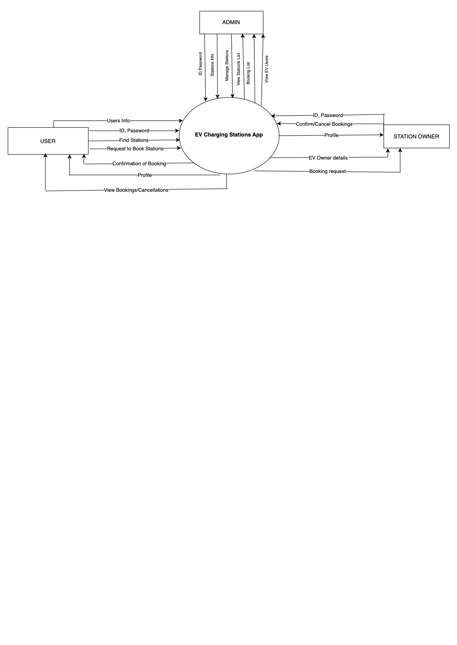
EV Charging Station App-Level 0 DFD

DFD LEVEL-0 DESCRIPTION

Entities:
- User: An electric vehicle owner who interacts with the app for station search and booking.
- Admin: Manages the system by controlling station and user data.
- Station Owner: Manages station information and handles booking requests.

Data Flow:
- User to EV Charging Stations App:
  - Sends ID and Password for login.
  - Requests to find stations and book stations.
  - Receives confirmation of booking.
  - Can view profile information and booking/cancellation details.
- Admin to EV Charging Stations App:
  - Sends ID and Password for login.
  - Manages station information and user data.
  - Can view the stations list, booking list, and EV user details.
- Station Owner to EV Charging Stations App:
  - Sends ID and Password for login.
  - Can confirm/cancel bookings.
  - Views EV owner details and booking requests.
  - Manages profile information.

Central Process (EV Charging Stations App):
- Manages all data related to users, station owners, and bookings.
- Handles data flow between the users, admin, and station owners.
- Maintains databases for user information, booking requests, and station details.

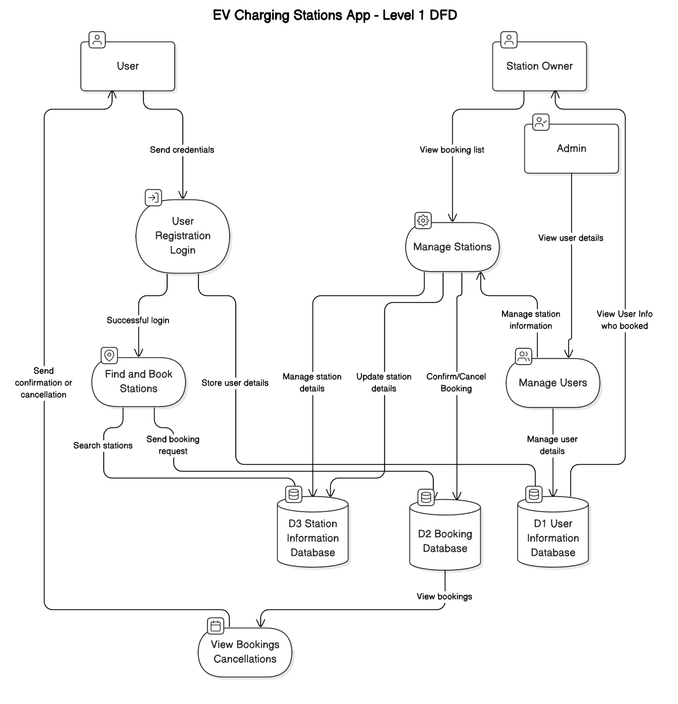

DFD LEVEL-1 DESCRIPTION

Entities:
- Admin: Manages users and station information.
- User: Registers, logs in, searches for stations, and makes bookings.
- Station Owner: Manages station details and views bookings.

Processes:
- User Registration and Login: The user provides an ID and password for authentication.
- Find and Book Stations: The user searches for available charging stations and requests to book a slot.
- Manage Stations: The station owner updates station information and views the booking list.
- Manage Users: The admin manages user information and handles booking confirmations or cancellations.
- View Bookings and Cancellations: Users and station owners can view booking statuses and cancellations.

Data Stores:
- User Information Database: Stores user profiles and login credentials.
- Booking Database: Stores booking requests and confirmations.
- Station Information Database: Stores station details.

Data Flow:
- The User sends login credentials to access the system.
- The User searches for stations and requests bookings.
- The Admin handles user management and confirms/cancels bookings.
- The Station Owner manages station data and views booking details.
- The system sends booking confirmations or cancellations to the user.
- All data is stored in the respective databases.

2.7 USE -CASE DIAGRAM
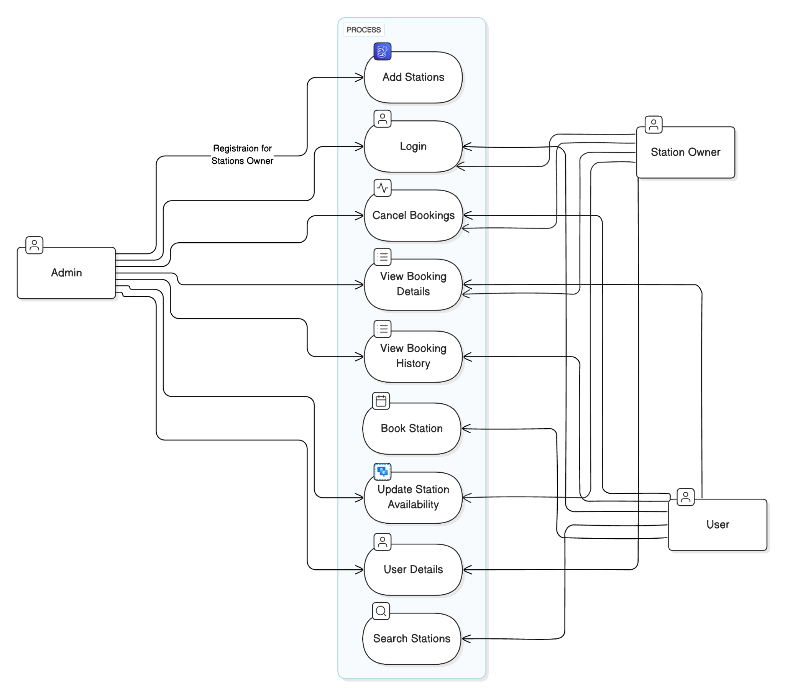

USE-CASE DIAGRAM DESCRIPTION

Actors:
- Admin – Manages the overall system, including users, station owners, and booking details.
- Station Owner – Manages charging station availability and updates station-related data.
- User – Searches, books, and manages their EV charging station reservations.

Use Cases and Their Interactions:
- Add Stations (Admin)
  - The admin adds new charging stations to the system, making them available for users.
- Login (Admin, Station Owner, User)
  - All users, including admins, station owners, and general users, must log in to access the system.
- Cancel Bookings (User, Admin, Station Owner)
  - Users can cancel their bookings. Admins and station owners may also cancel bookings if needed.
- View Booking Details (User, Admin, Station Owner)
  - Users can check the details of their reservations. Admins and station owners can also access this information.
- View Booking History (User, Admin, Station Owner)
  - Users can review their past bookings. Admins and station owners may also view booking histories for management purposes.
- Book Station (User)
  - Users can reserve an available charging station.
- Update Station Availability (Station Owner, Admin)
  - Station owners update the status of charging stations (e.g., occupied, available, under maintenance). Admins may have permissions to update availability as well.
- User Details (Admin)
  - The admin manages user information, including registration and verification.
- Search Stations (User)
  - Users can search for nearby available charging stations
2.8 ER DIAGRAM
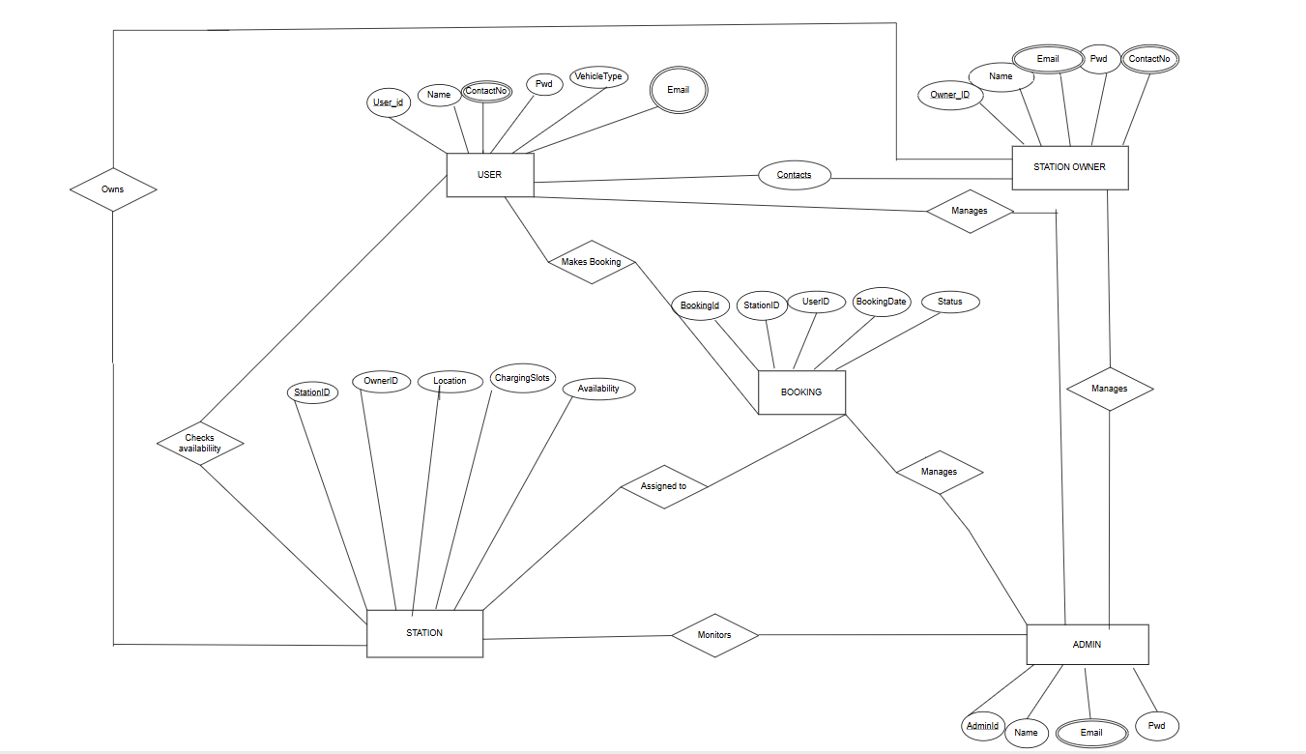

ENTITIES:
1.USER
Attributes:
- UserId
- Name,
- ContactNo
- Pwd
- VehicleType
- Email

2.STATION OWNER
Attributes:
- Owner_ID,
- Name
- Email
- Pwd
- ContactNo
- Availability of station
- Charging Slots
4.BOOKING
Attributes:
- BookingId
- UserID
- StationID
- BookingDate
- Status

5.ADMIN
Attributes:
- AdminID,
- Name
- Email
- Pwd

RELATIONSHIPS AND THEIR CARDINALITIES:
- USER — Makes Booking — BOOKING (1, M)
  - A user can make multiple bookings, but each booking belongs to one user.
- USER — Contacts — STATION OWNER(M, 1)
  - Multiple users can contact one station owner, but each user contacts only one owner at a time.
- STATION OWNER — Manages — STATION(1, M)
  - One station owner can manage multiple stations, but each station has only one owner.
- STATION — Checks Availability — USER(M, M)
  - Many users can check the availability of multiple stations.
- STATION — Assigned to — BOOKING(1, M)
  - A single station can have multiple bookings, but each booking is linked to only one station.
- BOOKING — Managed by — ADMIN (M,1)
  - An admin manages multiple bookings, but each booking is handled by only one admin.
- ADMIN — Monitors — STATION(1, M)
  - One admin can monitor multiple stations, but each station is monitored by one admin.
- ADMIN — Manages — STATION OWNER(1, M)
  - An admin manages multiple station owners, but each owner is managed by one admin.

2.9 SEQUENCE DIAGRAM

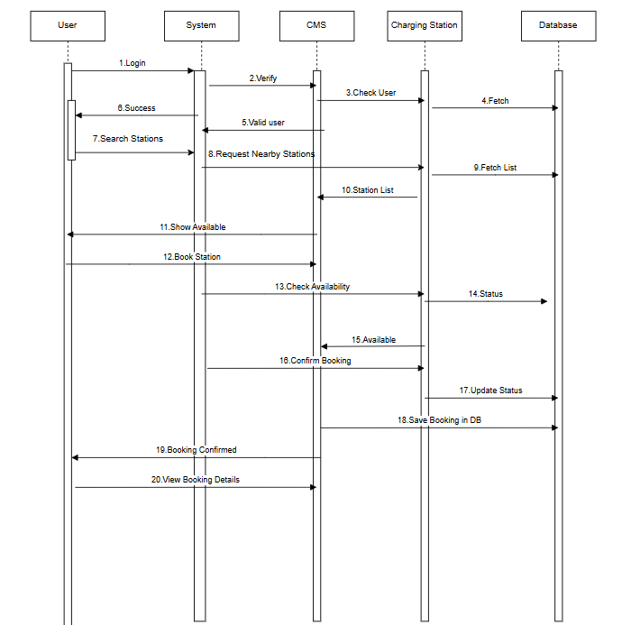
Book Station
SEQUENCE DIAGRAM DESCRIPTION- Book Station Function

Actors :
- User: The person who wants to book a charging station.
- System: The interface or platform used by the user.
- CMS (Central Management System): The backend logic handler that communicates with other services.
- Charging Station: Actual hardware unit for EV charging; communicates status and booking data.
- Database: Stores user details, station availability, and booking records.

Process Flow Description:
- Login Process:
  - The user logs in to the system.
  - The system sends login data to the CMS for verification.
  - CMS checks the user by communicating with the charging station and fetching user data from the database.
  - Once validated, the system sends a success response to the user.
- Search Stations:
  - The user initiates a station search.
  - The system requests nearby station data from CMS.
  - CMS retrieves the station list through the charging station which accesses the database.
  - The station list is shown to the user.

- Booking Process:
  - The user chooses a station and initiates booking.
  - The system forwards the request to CMS, which checks availability by querying the charging station.
  - The charging station returns its status (available or not).
  - If available, CMS confirms the booking.
  - The charging station updates its availability, and CMS saves the booking in the database.
  - The system notifies the user that the booking is confirmed.
- View Booking:
  - The user can request to view booking details after successful booking.

2.Login Function

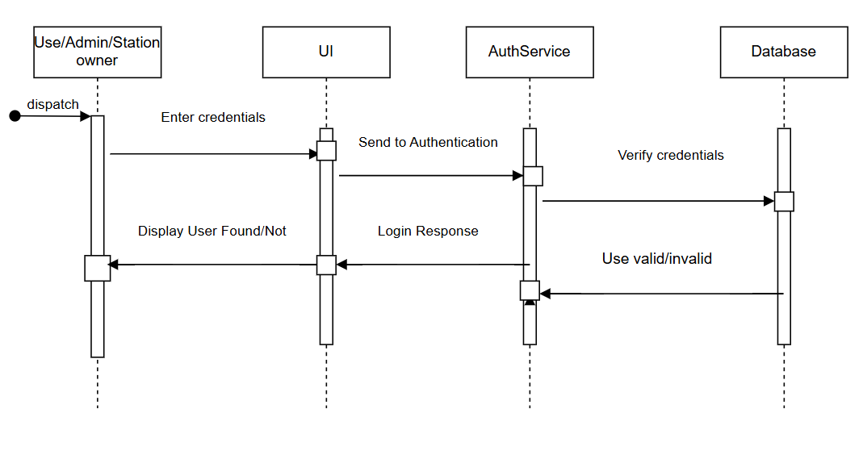

SEQUENCE DIAGRAM DESCRIPTION-Login Process Function
Actors:
- User: Person logging into the app.
- System (UI): Interface where user inputs login details.
- AuthService (part of CMS): Handles authentication logic.
- Database: Stores user credentials and profile data.
Process Flow:
- The user enters login credentials on the system UI.
- The system UI sends the credentials to AuthService for authentication.
- The AuthService queries the Database to verify the user credentials.
- If the user exists and the password matches, the Database returns valid credentials.
- The AuthService sends a success response back to the system UI.
- The system UI displays a login success message to the user.

3. Search Stations Function

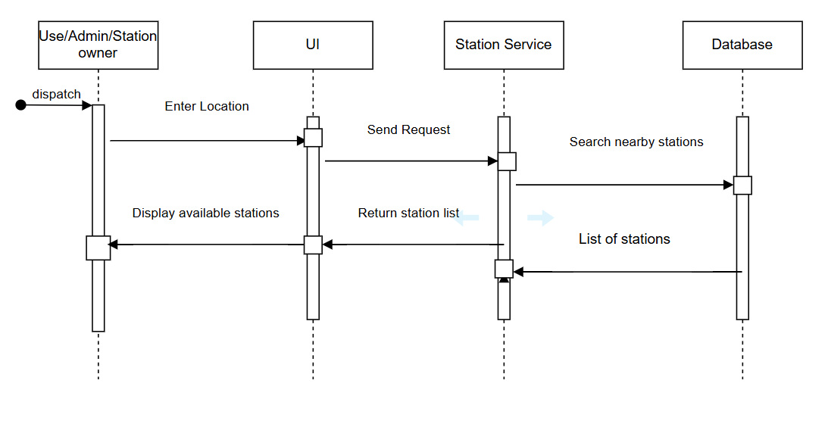

SEQUENCE DIAGRAM DESCRIPTION-Search Stations Function

Actors:
- User: The person searching for a charging station.
- System (UI): Platform where user initiates the search.
- StationService (CMS): Processes the request and fetches nearby stations.
- Database: Stores station location and availability.
- Charging Station: (implicitly queried for real-time data).
Process Flow:
- The user initiates a station search on the system UI.
- The system UI sends the location/request to the StationService.
- The StationService queries the Database to fetch nearby stations.
- Optionally, the StationService may ping charging stations for real-time availability.
- The list of available stations is returned to the system UI.
- The user sees a display of nearby available stations.

4.Update Station Availability Function
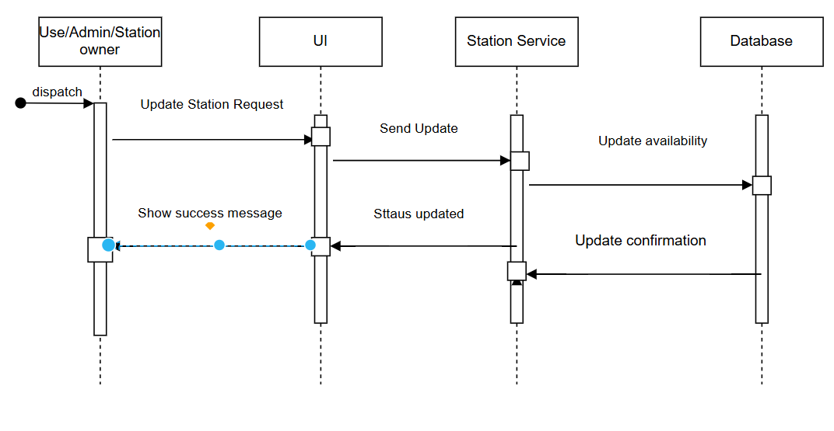

SEQUENCE DIAGRAM DESCRIPTION-Update Station Availability Process
Actors:
- Station Owner / Admin: The person updating the availability status.
- UI (Frontend): The interface used to initiate the update.
- StationService (Backend): The logic handler that processes the update.
- Database: Stores updated availability status of stations.
Process Flow:
- The Station Owner / Admin initiates an Update Status Request from the UI.
- The UI (Frontend) sends the update data to the StationService (Backend).
- The StationService validates the request and sends an Update Availability command to the Database.
- The Database performs the update and returns an Update Confirmation to the StationService.
- The StationService sends a Status Updated response back to the UI.
- The UI shows a Success Message to the Station Owner / Admin, confirming the availability status has been updated.

5.Add Stations Function

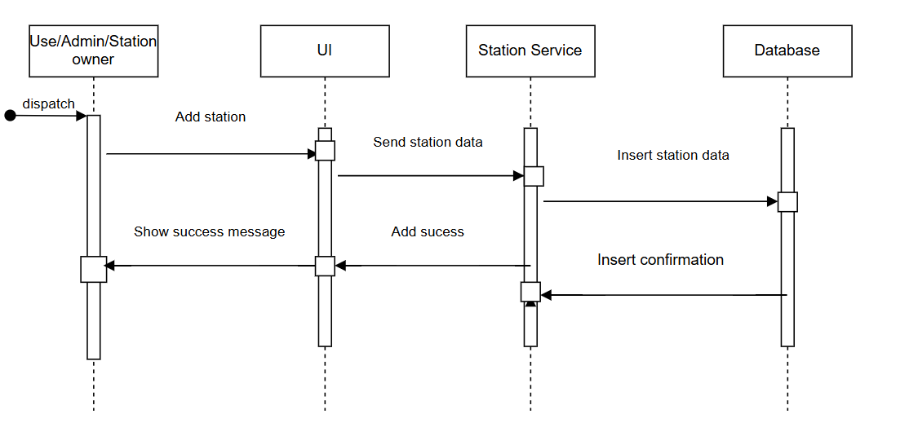

SEQUENCE DIAGRAM DESCRIPTION-Add Stations Function
Actors:
- Admin / Station Owner: The person adding a new station.
- UI (Frontend): Interface used to submit new station details.
- StationService (Backend): Handles validation and processing of new station data.
- Database: Stores station details.
Process Flow:
- The Admin logs into the UI.
- The Admin fills out and submits the Add Station form.
- The UI sends the new station data to the StationService.
- The StationService validates the data (e.g., location, capacity).
- Upon successful validation, the StationService writes the station info to the Database.
- The Database confirms the addition.
- The StationService sends an acknowledgment back to the UI.
- The UI shows a Success Message to the Admin confirming station addition.

6.Cancel Bookings
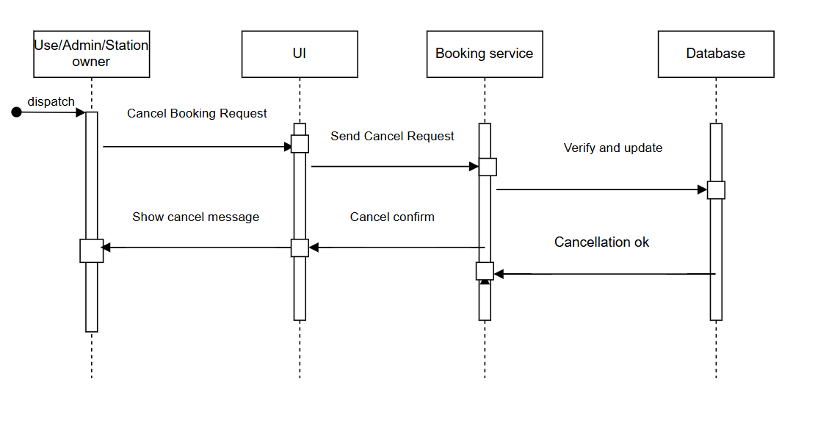

SEQUENCE DIAGRAM DESCRIPTION-Cancel Bookings
Actors:
- User: The person who made the booking.
- UI (Frontend): Interface to request booking cancellation.
- BookingService (Backend): Manages booking data and availability.
- Database: Stores bookings and station availability.
Process Flow:
- The User navigates to their bookings and clicks Cancel Booking on the UI.
- The UI sends a Cancellation Request to the BookingService.
- The BookingService verifies booking status and user access.
- If valid, it updates the Database to remove or mark the booking as canceled.
- The BookingService optionally notifies the Charging Station to mark the slot as available.
- The Database confirms cancellation.
- The BookingService returns a successful response to the UI.
- The UI shows a Cancellation Confirmation message to the User.

Visual Overview Of Web Application Components
      - Home Page
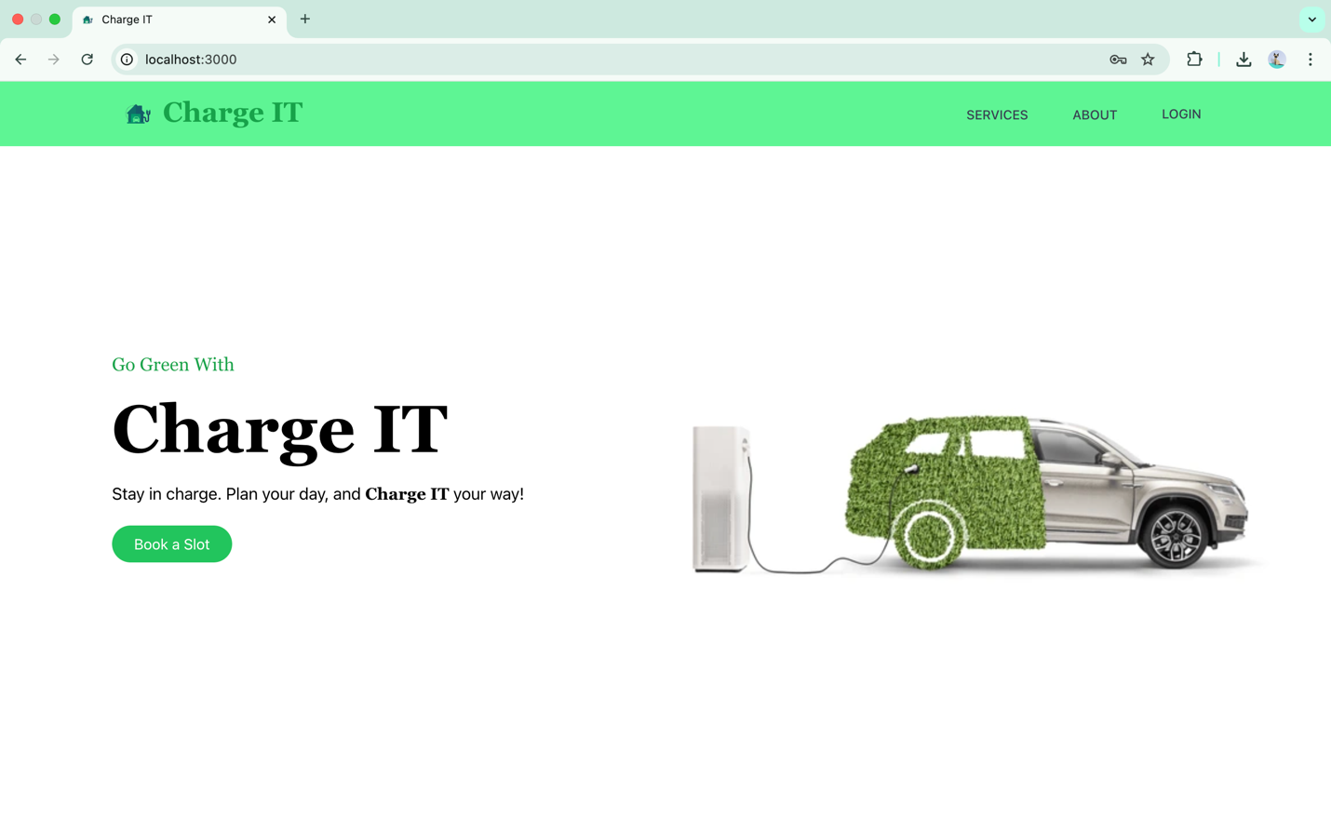
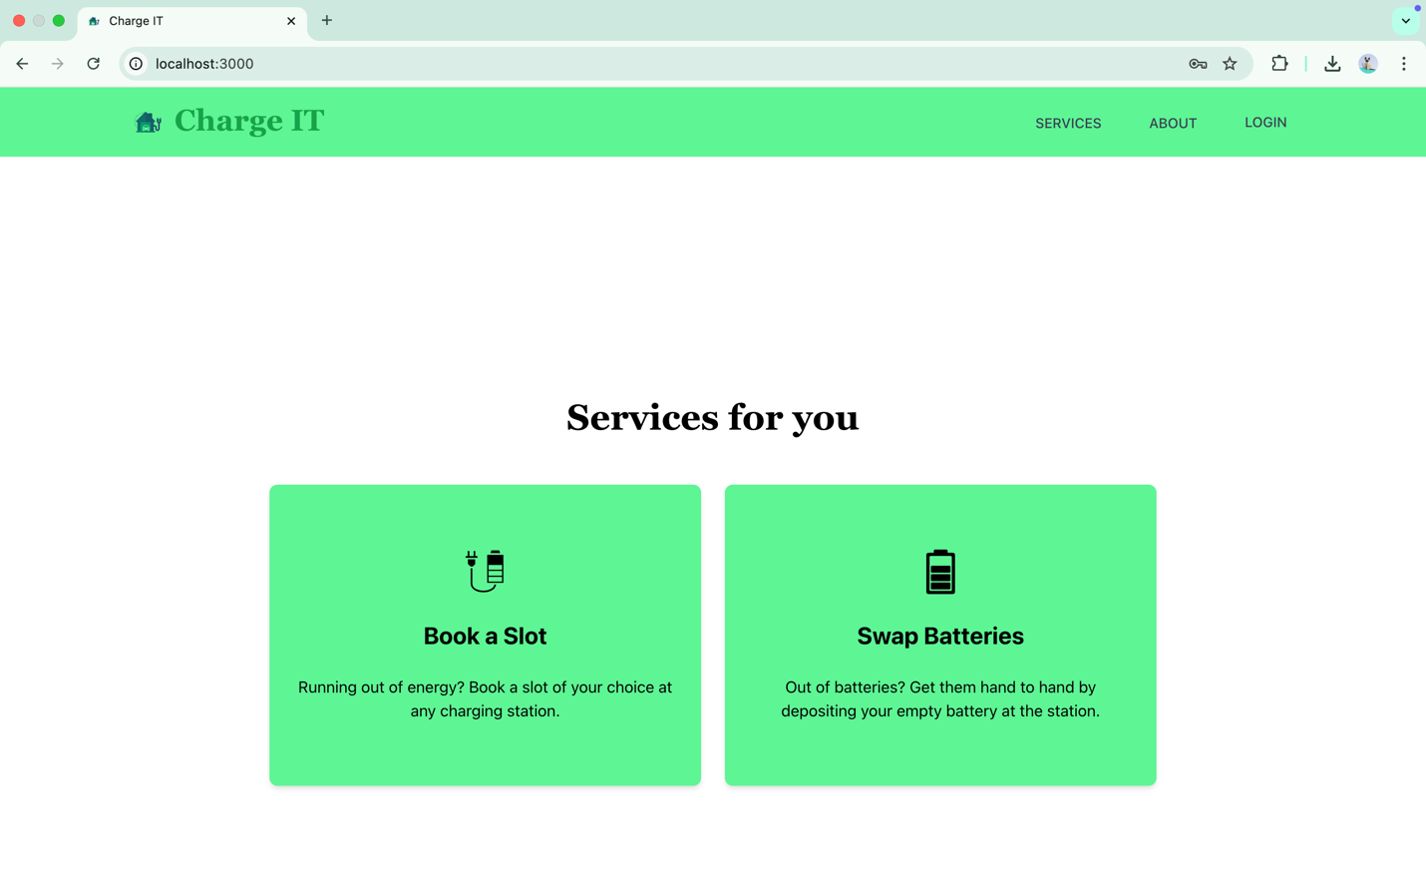
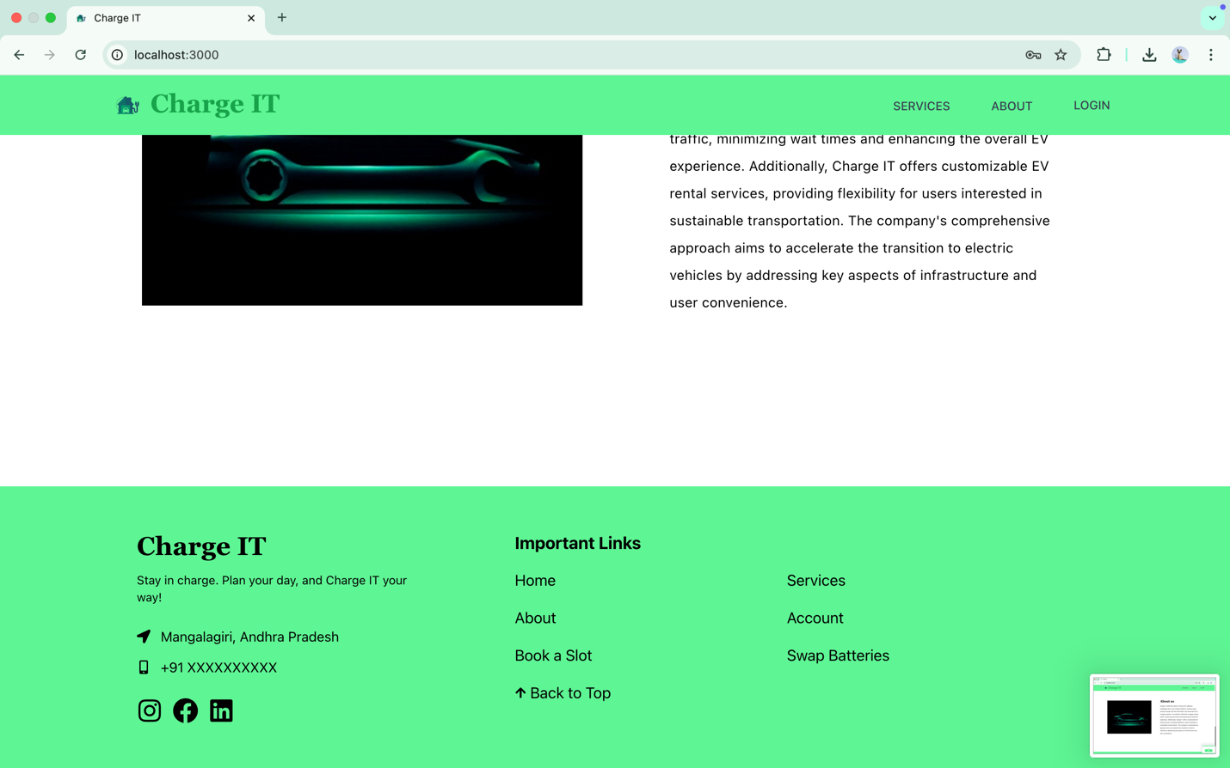
The homepage showcased above embodies the gateway to the web application, offering users their first glimpse into its functionality and features. It serves as the starting point for navigation and interaction, providing a central hub for accessing various functionalities and content within the platform.

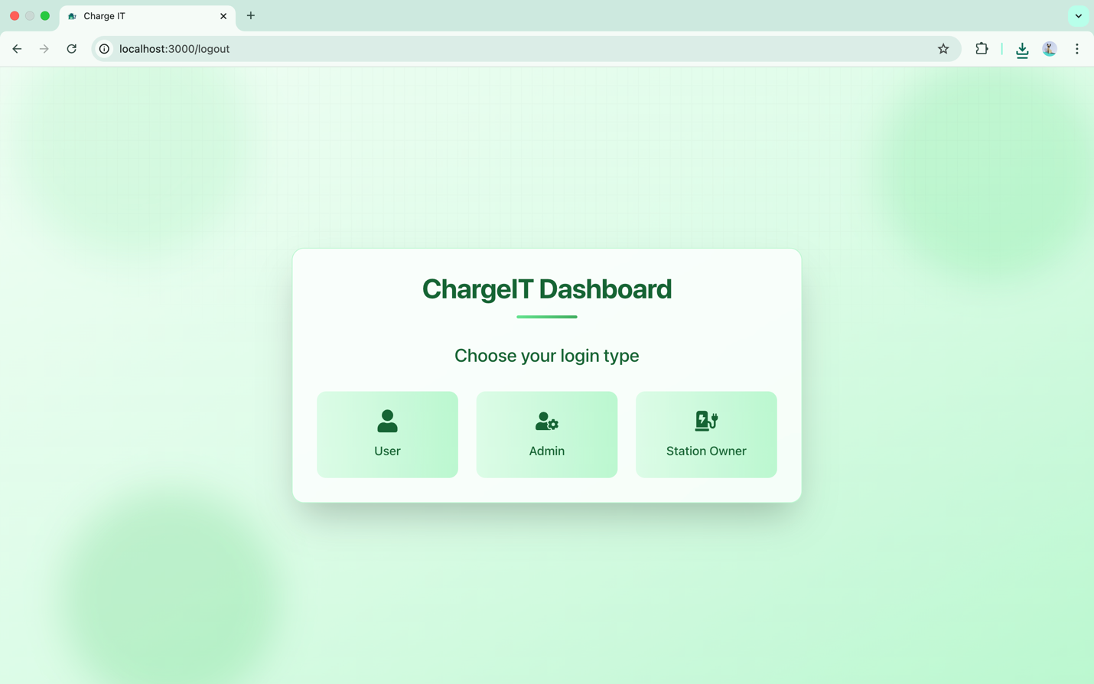
      - Role Selection Page
This page serves as the login selection interface for the ChargeIT Dashboard, allowing users to choose between three roles: User, Admin, or Station Owner. It's the first point of interaction after visiting the site.

      - User Login/Signup Page
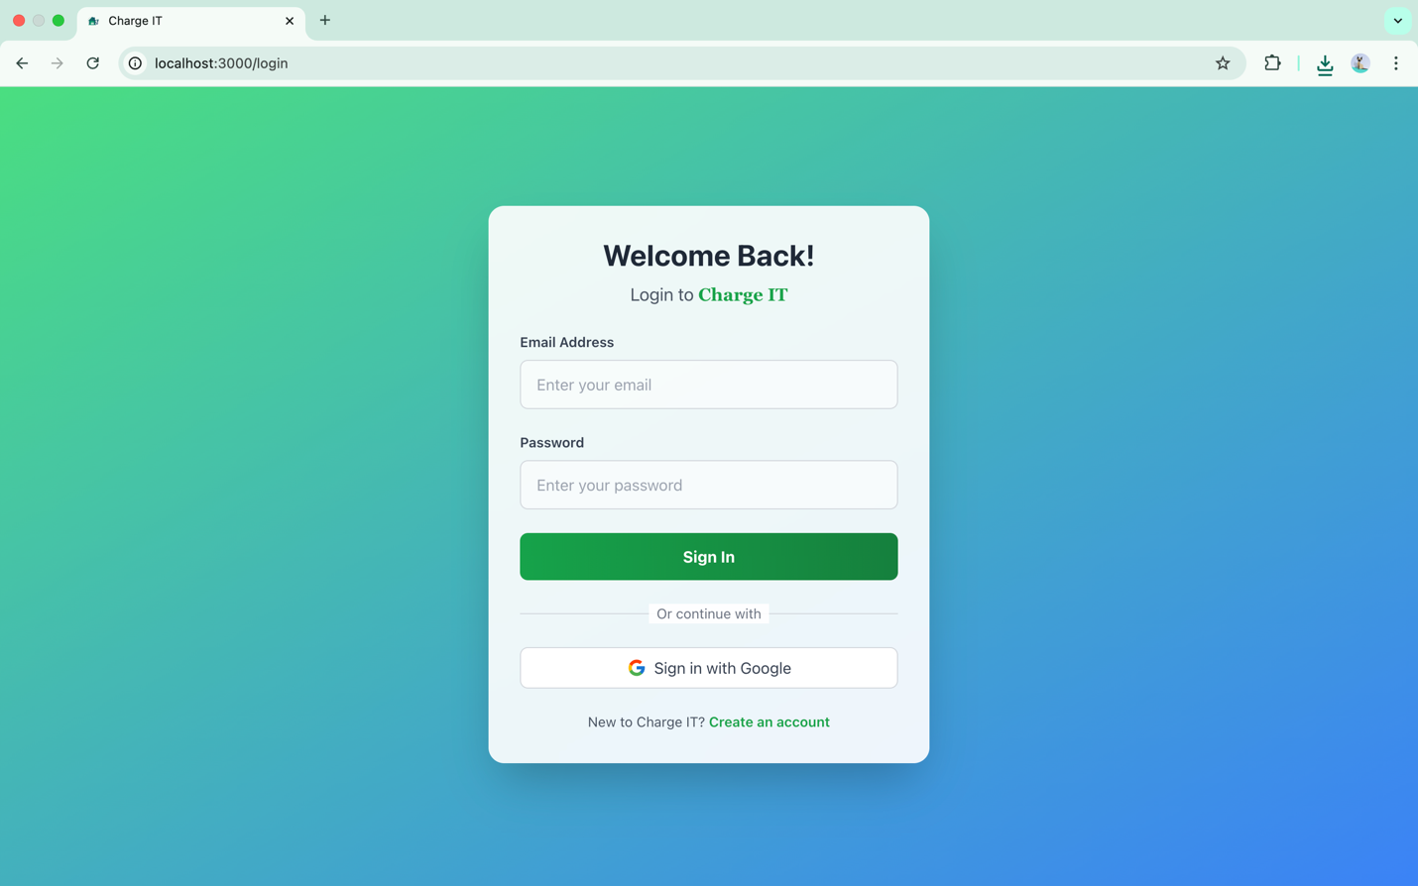

      - Admin Login Page
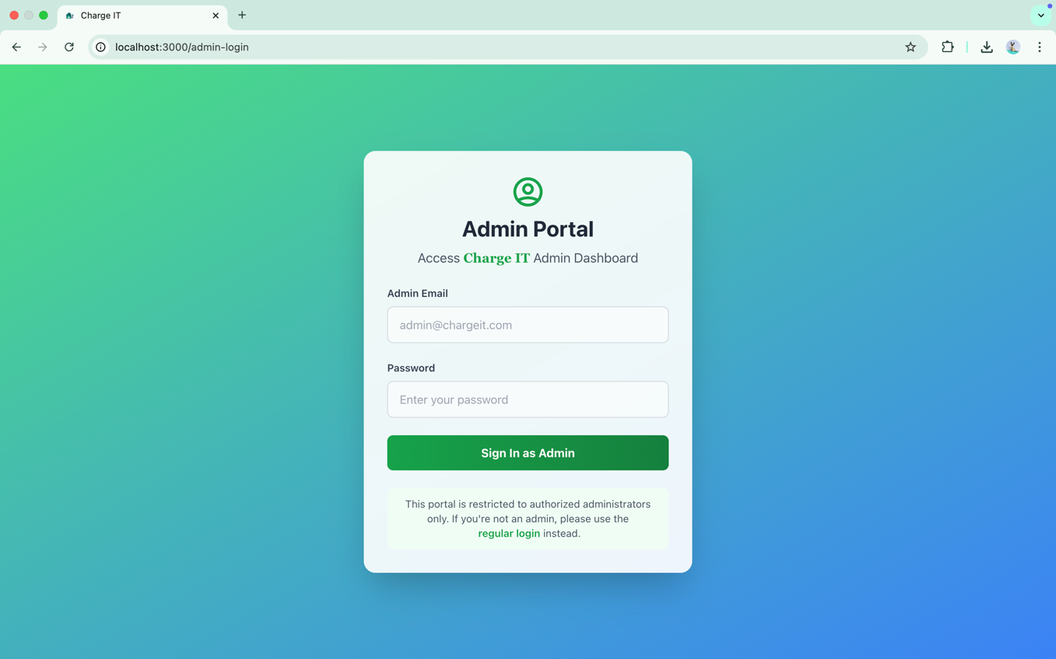
      - Station Owner Login Page
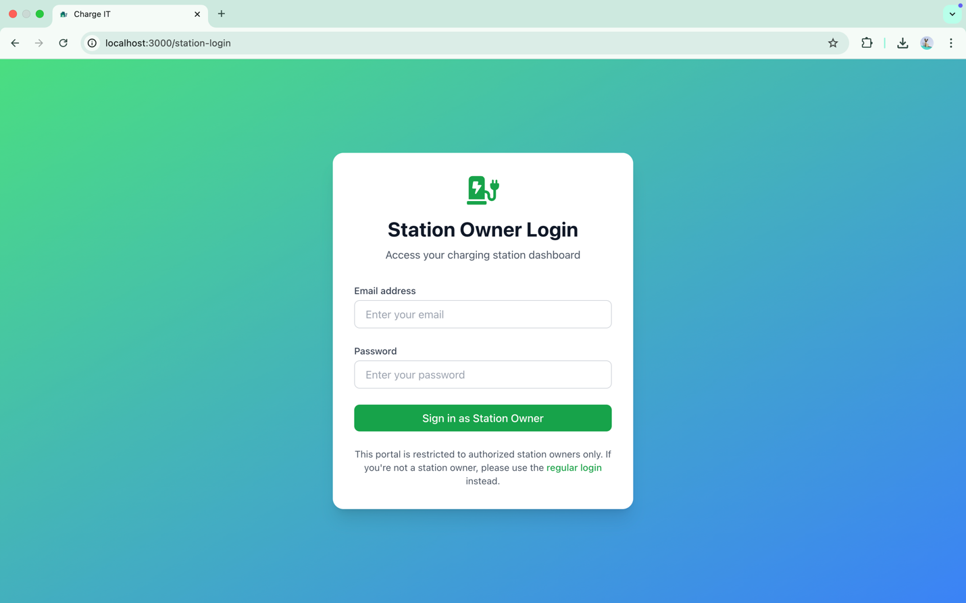

      - User DashBoard
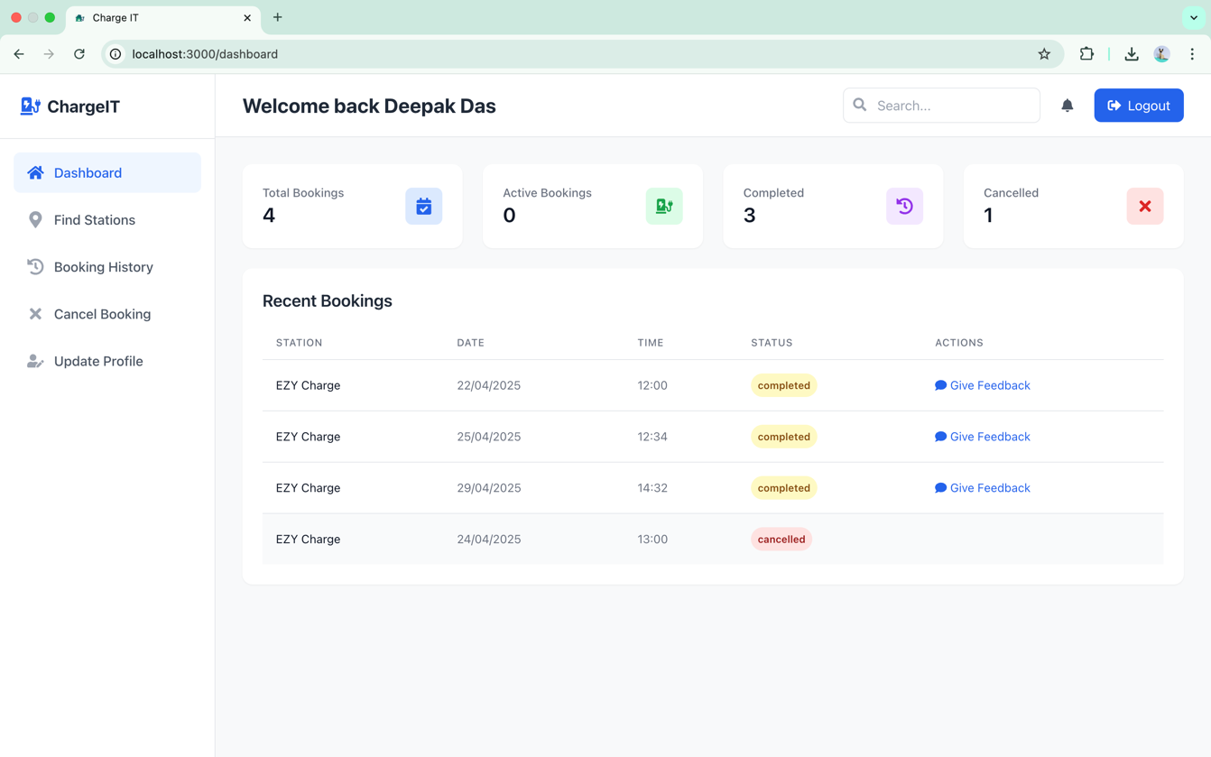
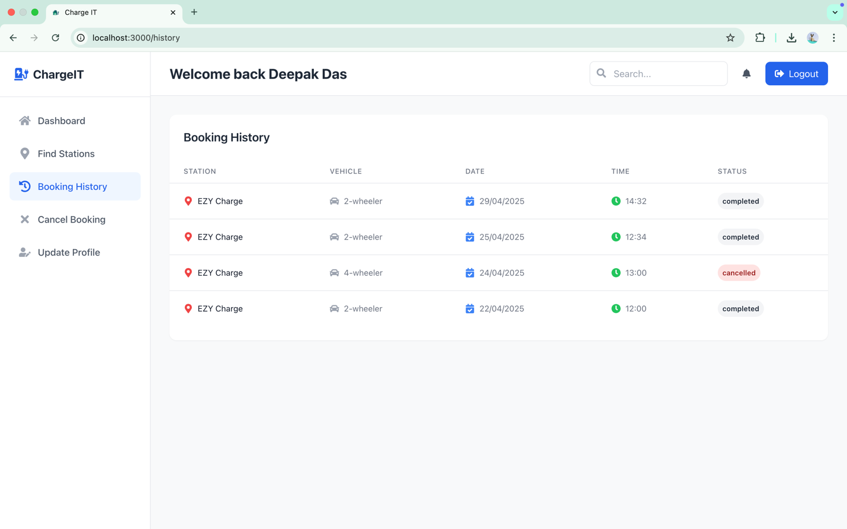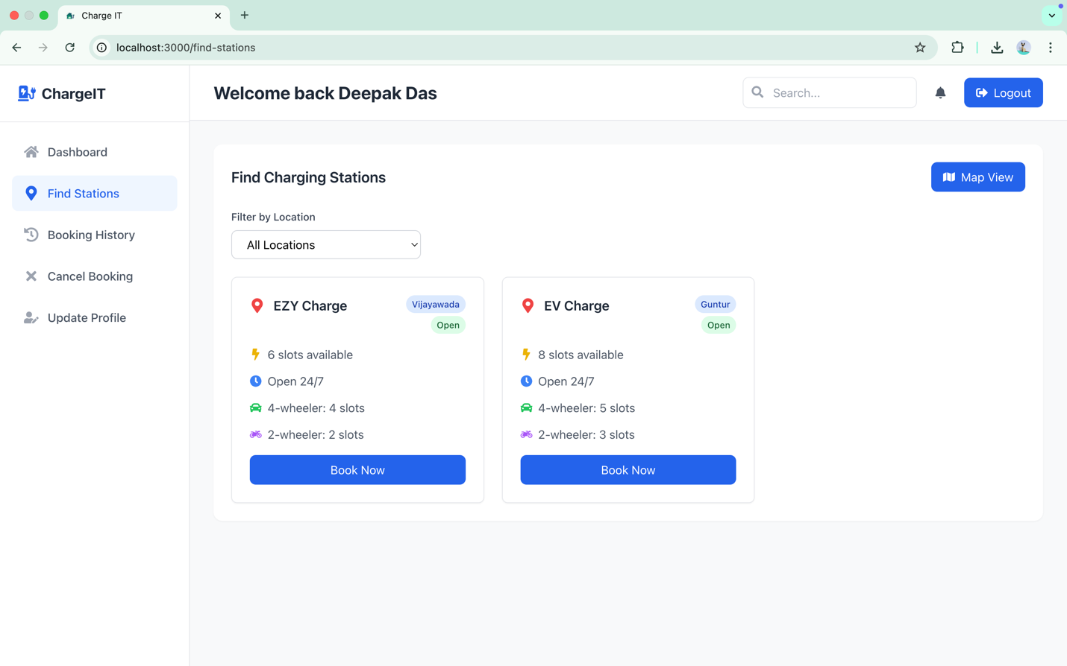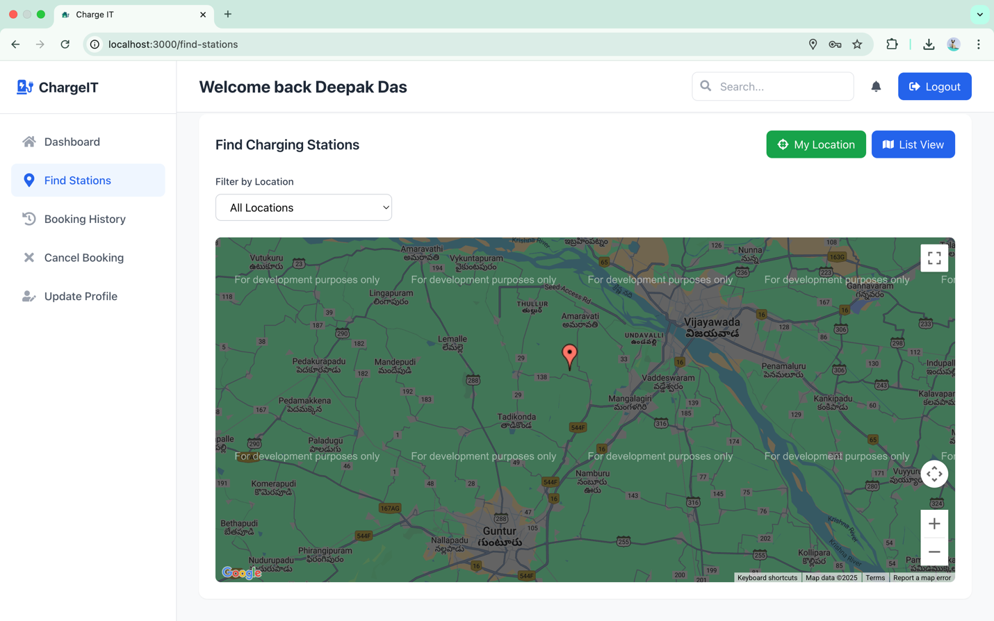

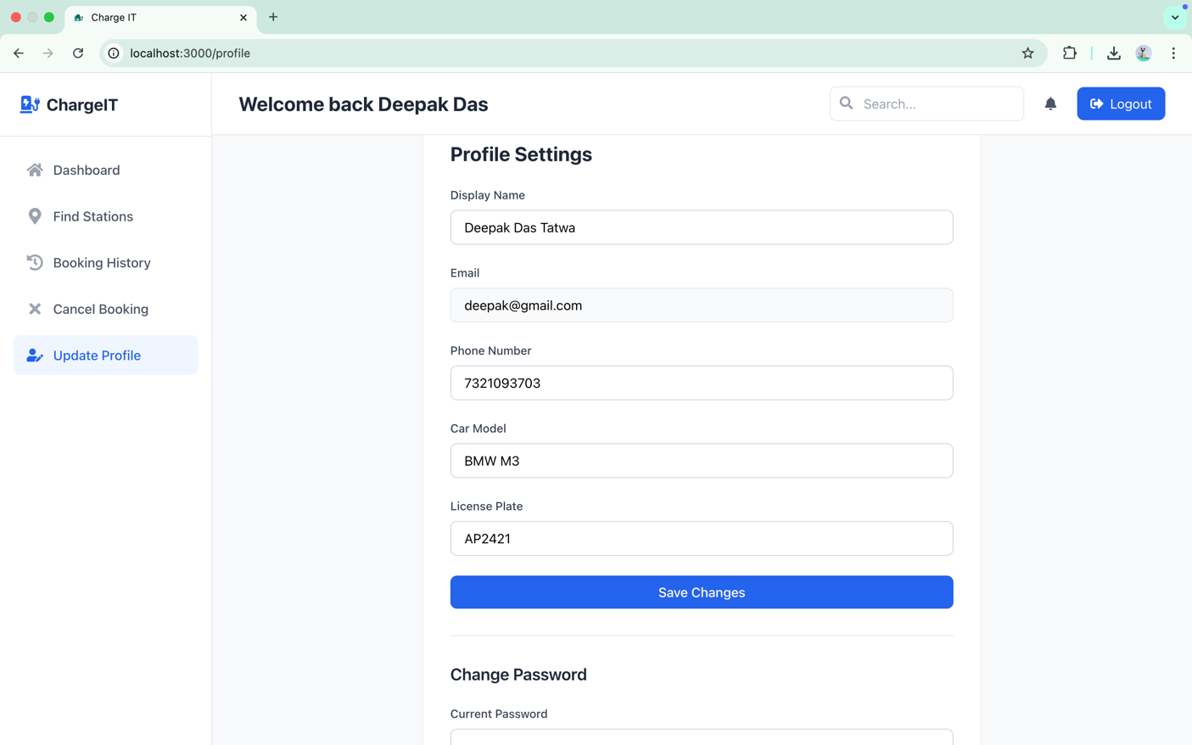
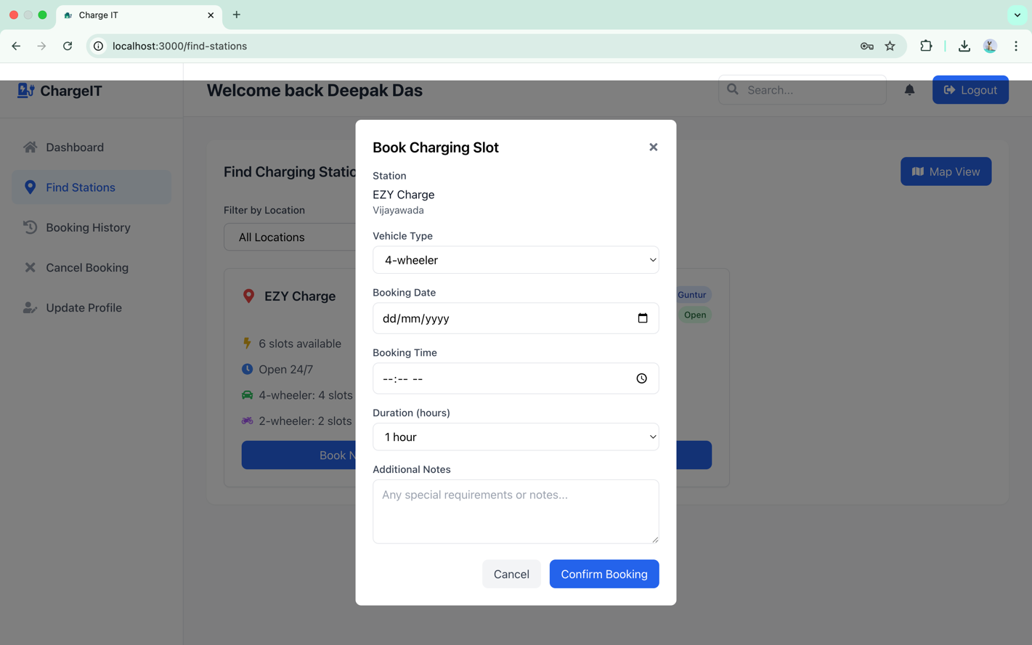
In this user dashboard, a user can see all the bookings and number of booking done and can see the station by searching with location and can book the station accoring to the date and time and can also update the profile of user such as change car name, name, model , change passwords.

      - Admin DashBoard Page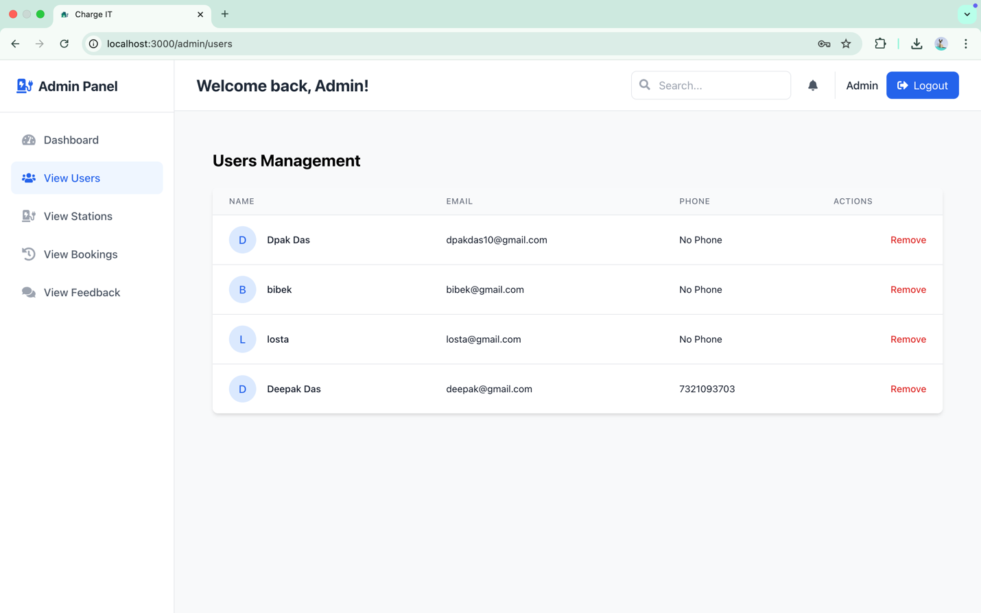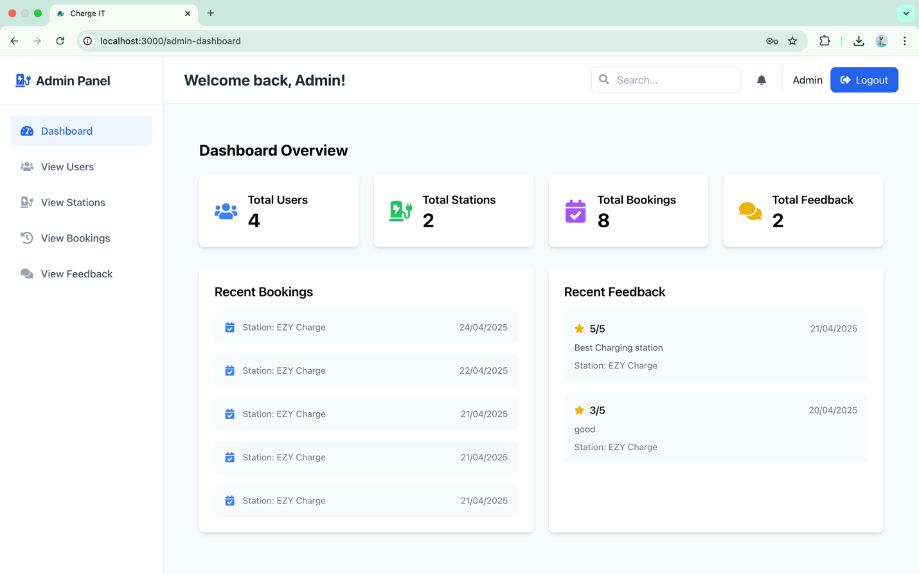
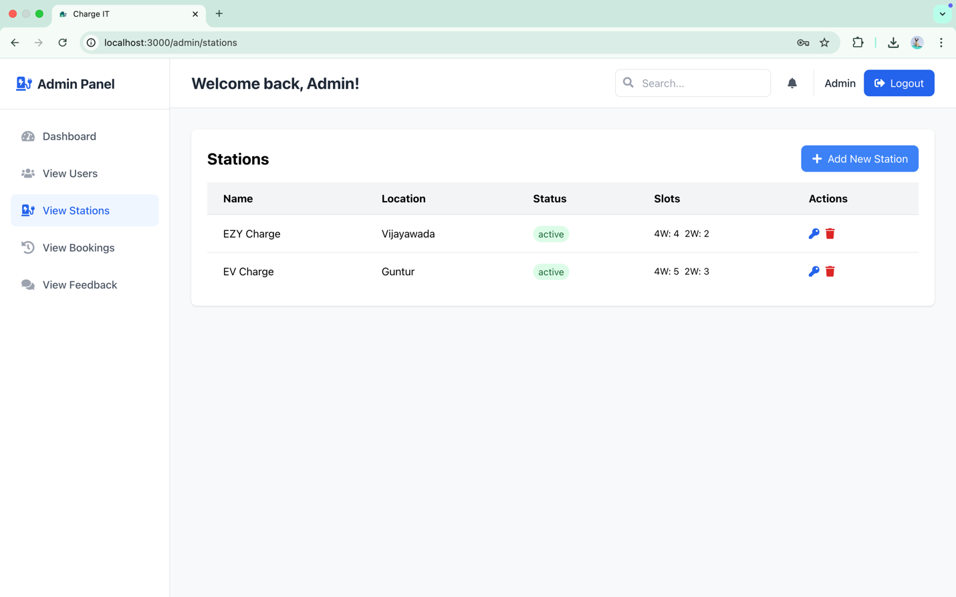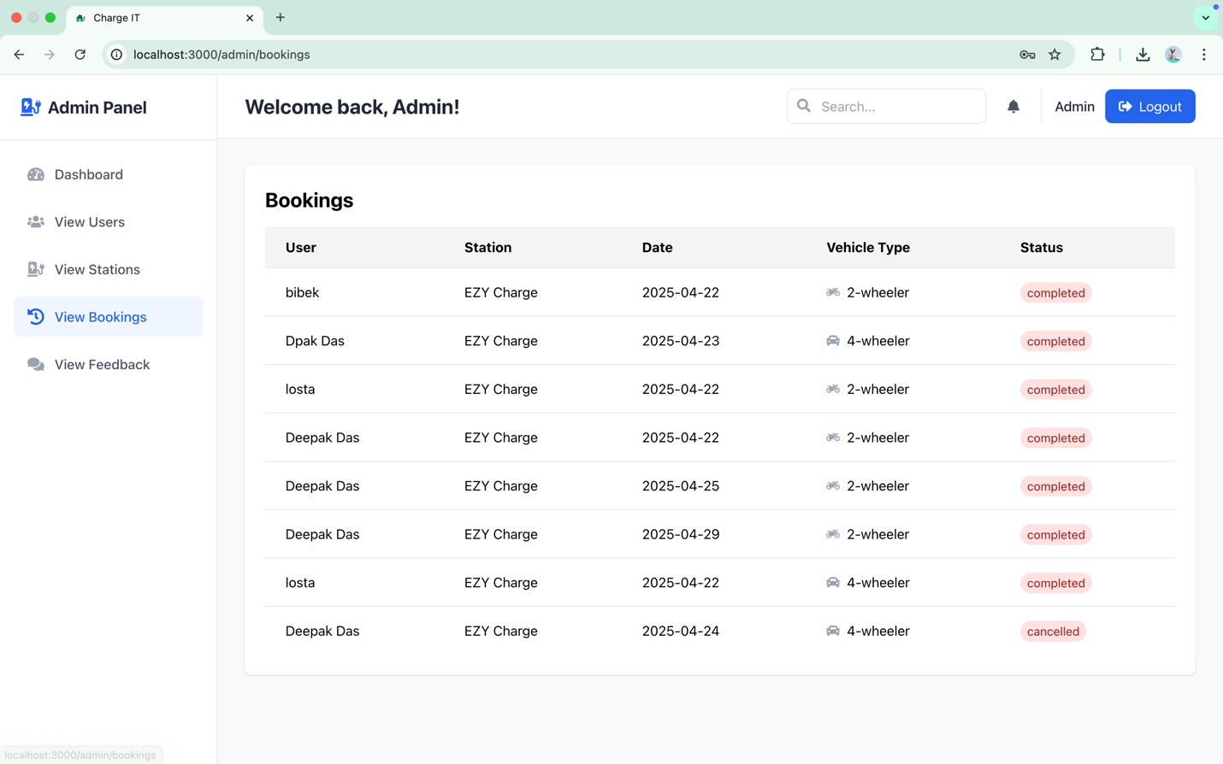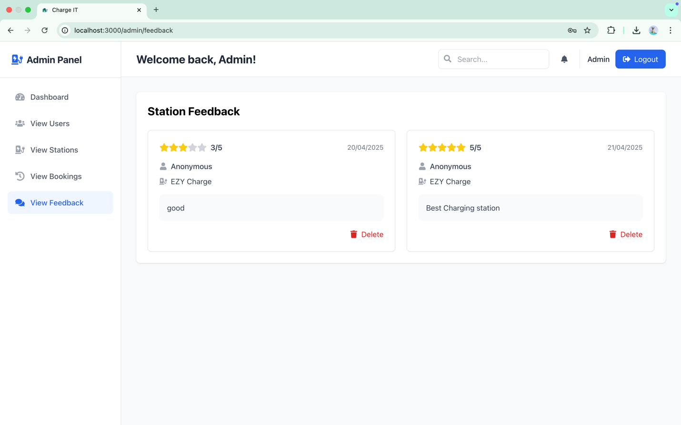
This page allows only authorized Admins to log in and access the dashboard. The Admin can view and manage all user bookings, monitor station owner activities, and oversee registered users with the ability to remove any if necessary. They can also manage charging stations by adding new ones, providing login credentials to station owners, and deleting stations if any unusual activity is detected. Additionally, the Admin can view user feedback for each station to ensure quality and service standards.

8. Station Owner DashBoard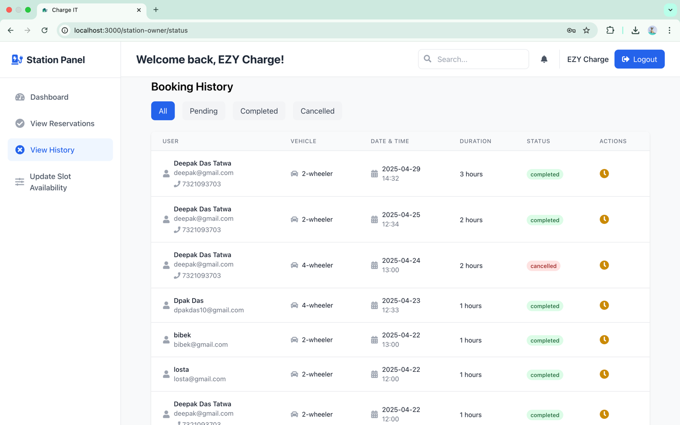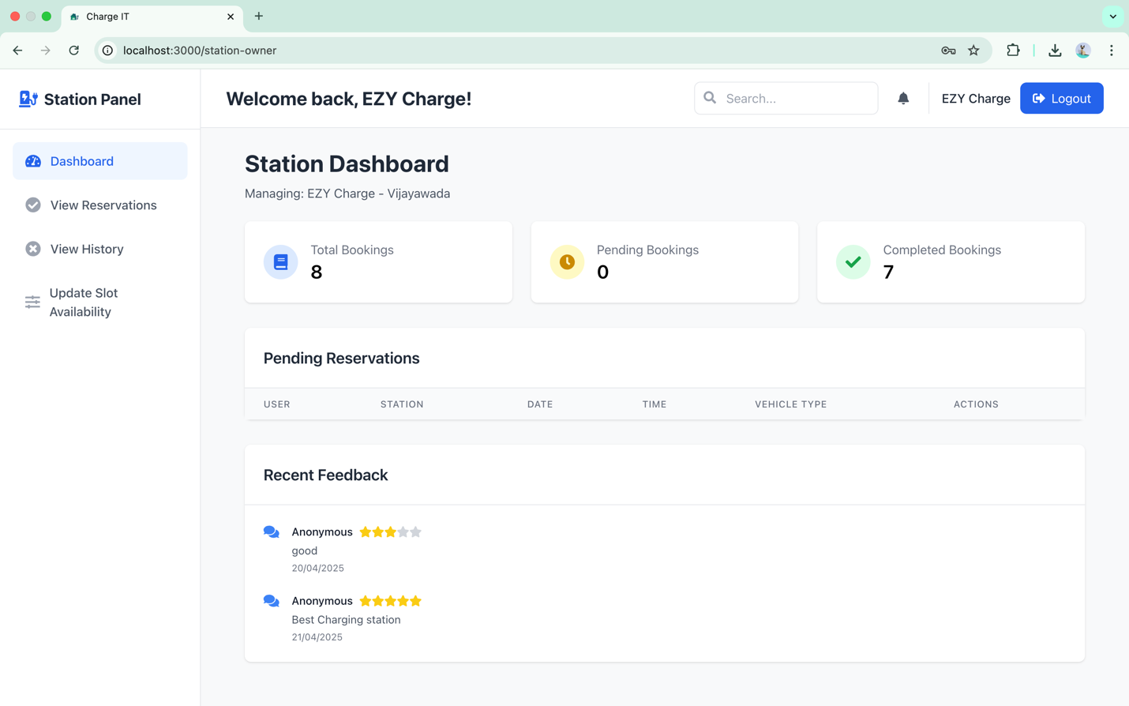
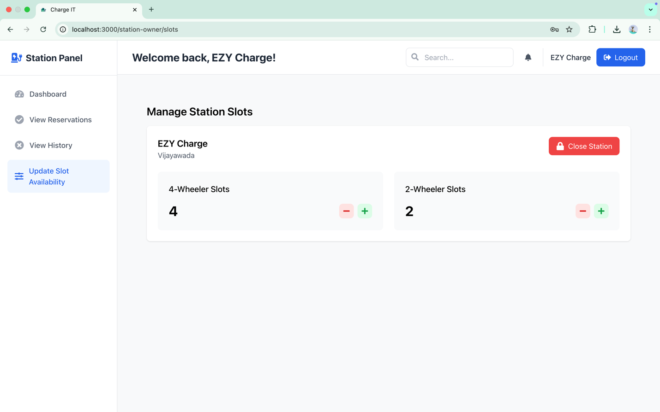

This is the Station Owner Dashboard for respective station. It displays key booking metrics including total bookings, pending bookings, and completed bookings. Station owners can view upcoming reservations, check booking history, update slot availability, and monitor user feedback to maintain service quality.

Conclusion
The EV Charging Management System stands as a robust, scalable, and innovative web-based platform tailored to meet the evolving demands of the electric vehicle ecosystem. By integrating user-friendly interfaces and real-time functionalities such as station discovery, slot reservation, route planning, and feedback management, the system delivers a seamless experience for EV users. The role-based architecture—comprising User, Admin, and Station Owner modules—ensures that each stakeholder can efficiently manage their responsibilities. Admins have full control over system operations, including managing users, stations, and bookings, and ensuring data security through JWT authentication. Station owners can effortlessly monitor station activities and availability, contributing to improved service delivery.
This project not only simplifies the charging process but also addresses major issues such as long wait times, lack of station visibility, and inefficient resource allocation. By reducing range anxiety and supporting proactive infrastructure management, the system fosters trust and convenience among EV users. Furthermore, its adaptability for smart cities, highways, and corporate fleets highlights its potential for future expansion. In essence, the EV Charging Management System is a meaningful step toward promoting clean energy, reducing carbon emissions, and encouraging the widespread adoption of sustainable transportation solutions.

